PORTFOLIO
ASSIGNMENT OF CSE111 (ORIENTATION TO COMPUTING-1)
COMPUTER SCIENCE AND ENGINEERING
Submitted by: ABHINAV JHA
Name: ABHINAV JHA
Registration number:12406442
Roll No.: 44
Section: K24FD

Submitted to: Dr. Harjit Singh


LOVELY PROFESSIONAL UNIVERSITY

DECLARATION
I, Abhinav Jha a student of Bachelor of Technology under CSE discipline at Lovely Professional University, Punjab, hereby declare that all the information furnished in this project report is based on my own work and is genuine

Registration Number : 12406442

Platforms for profile creation | Link to student profile | Screenshot
Figma | Since internal profile doesn’t work, so I am attaching project link  Project1:  https://www.figma.com/design/K7vW4b6UQ4mOi6lHP5Mb8A/Figma-first-project?node-id=0-1&node-type=canvas&t=pgDGQbd10lHeVYB3-0 | 1
Quora | https://www.quora.com/profile/Abhinav-Jha-566 | 2
Stack overflow | https://stackoverflow.com/users/28520069/abhinav-jha | 3
Hacker Rank | https://www.hackerrank.com/profile/abhinavjha658 | 4
Hacker Earth | https://www.hackerearth.com/@abhinavjha658/ | 5-6
Geeks for Geeks | https://www.geeksforgeeks.org/user/abhinavd3up/ | 7
GitHub | https://github.com/abhianvjha | 8
Git |  | 9
LinkedIn | https://www.linkedin.com/in/abhinavjhaaa/ | 10
Technical mooc  registration Link and screenshot | https://skillera.org/ExploreCoursesEthicalHacking | 11

FIGMA
Profile:
Figma internal profile with project
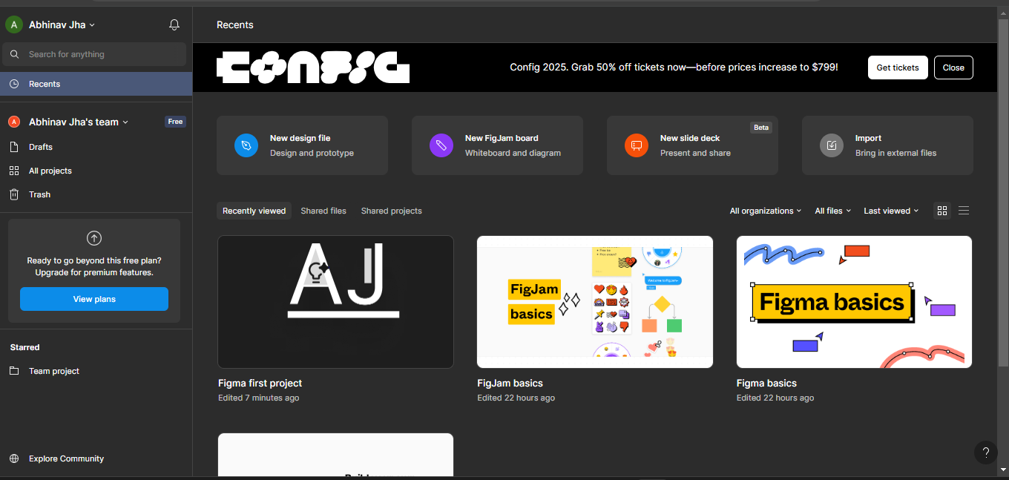
Accomplishment:
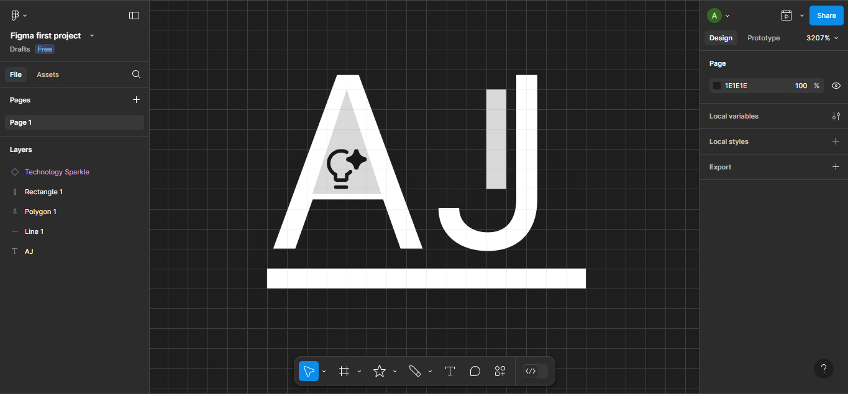

QUORA
PROFILE AND ACCOMPLISHMENT:

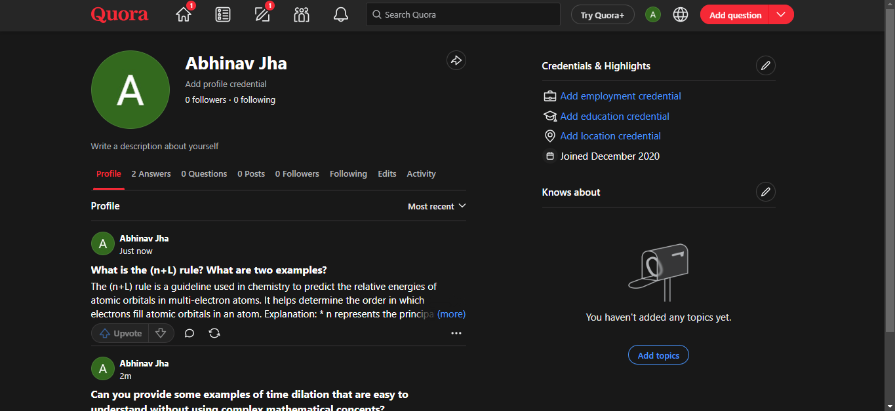

STACKOVERFLOW
PROFILE:
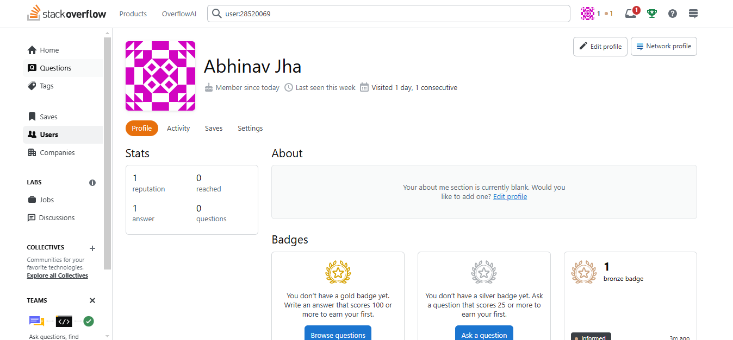
Accomplishment: Raised a question and got a badge
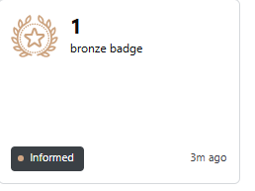

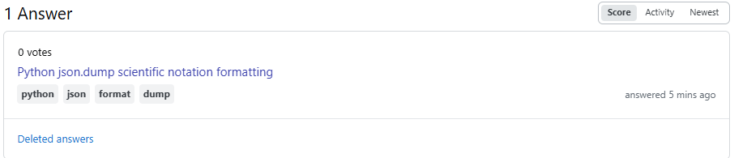

HACKER RANK
Profile:
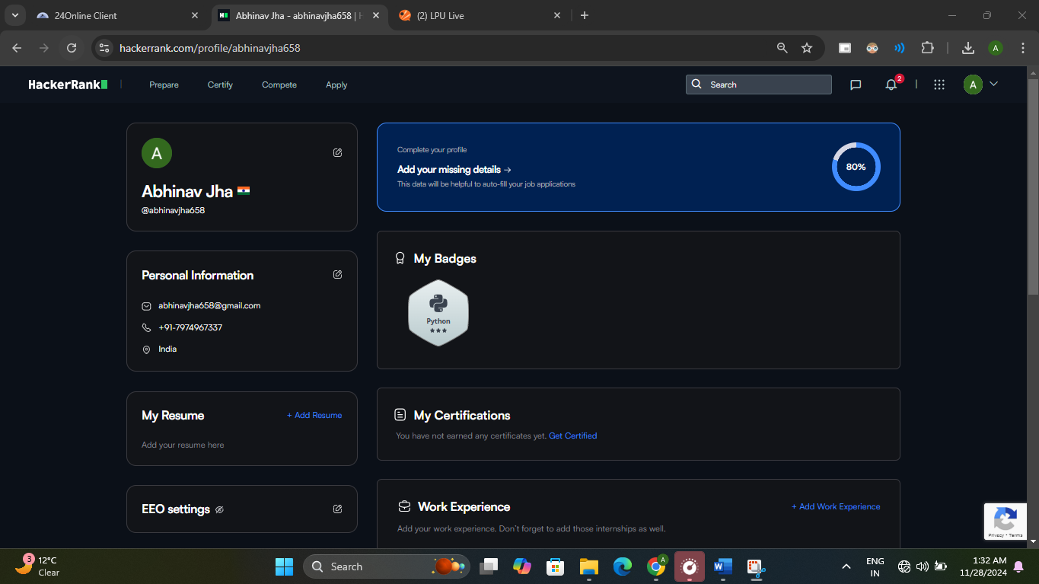
Accomplishment:
Achieved a three-star badge in python by solving question.

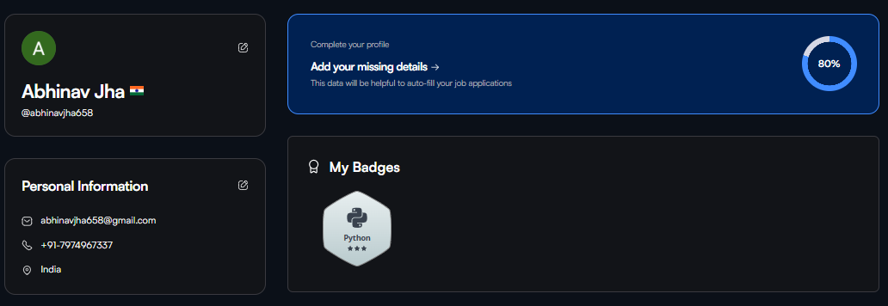

HACKER EARTH
Profile:

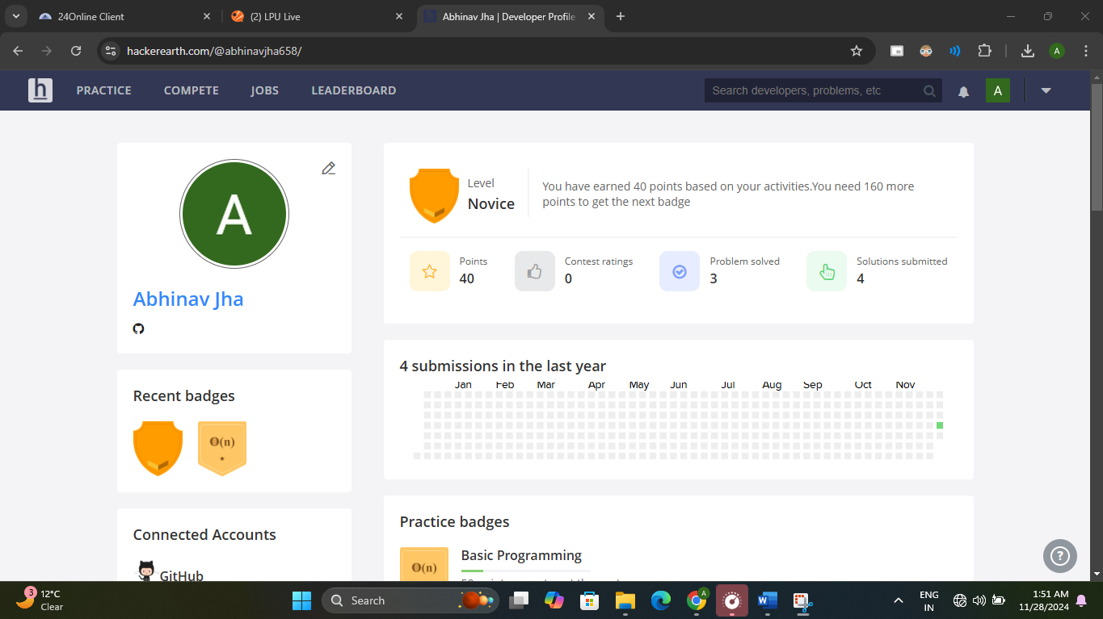
Accomplishment:
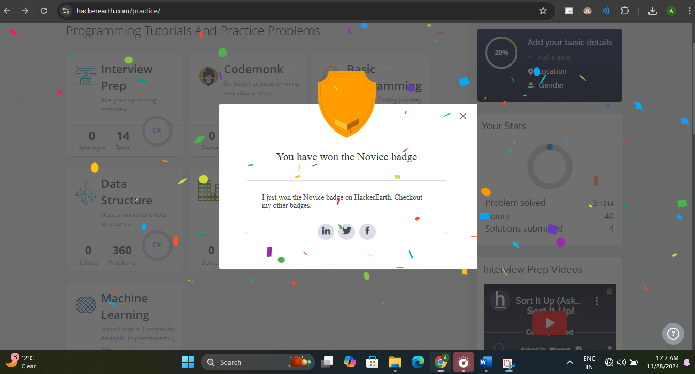

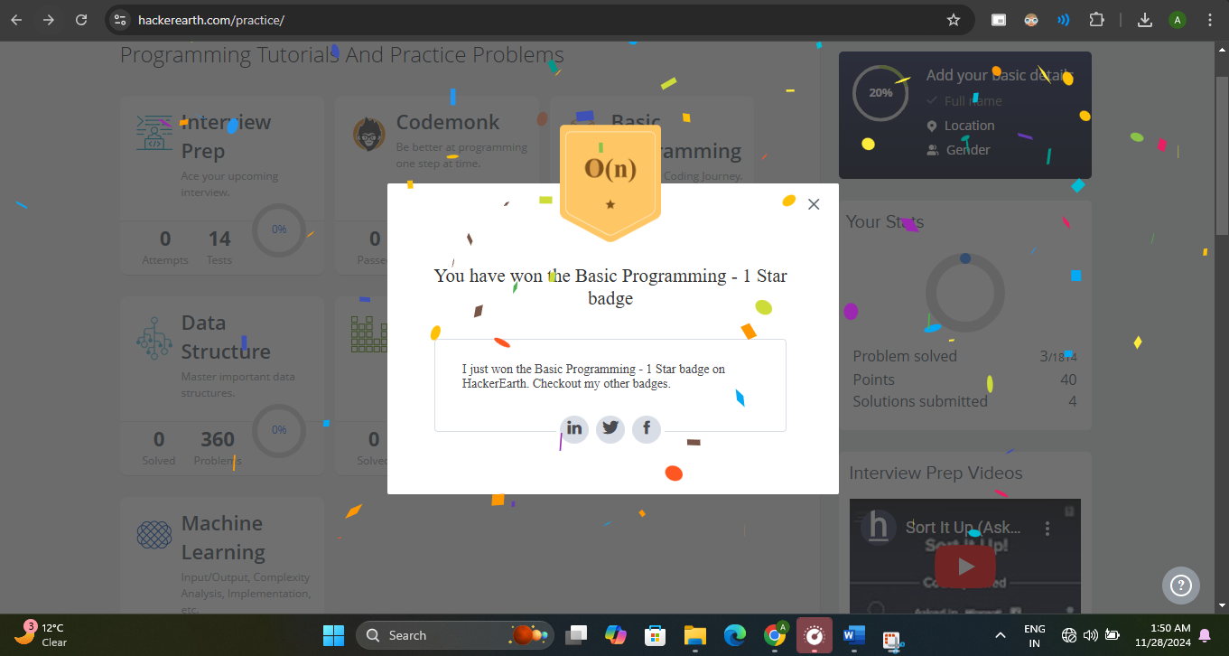

6

GEEKS FOR GEEKS
Profile:
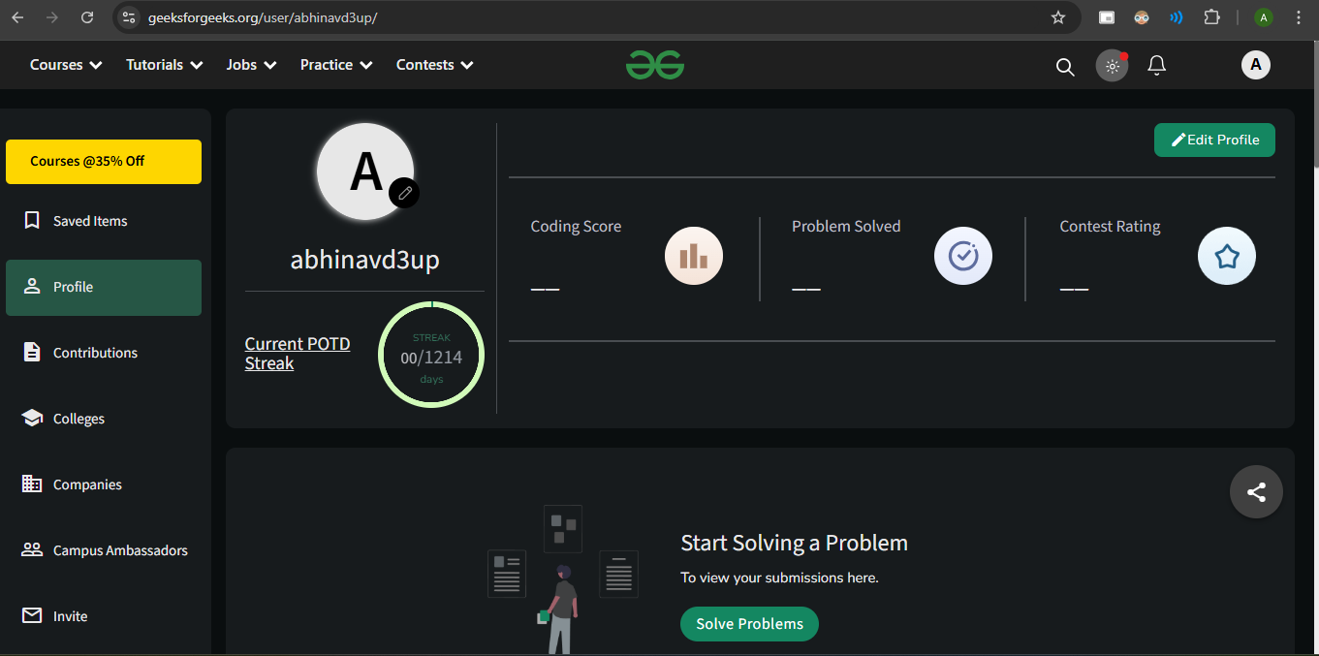

GITHUB
Profile:
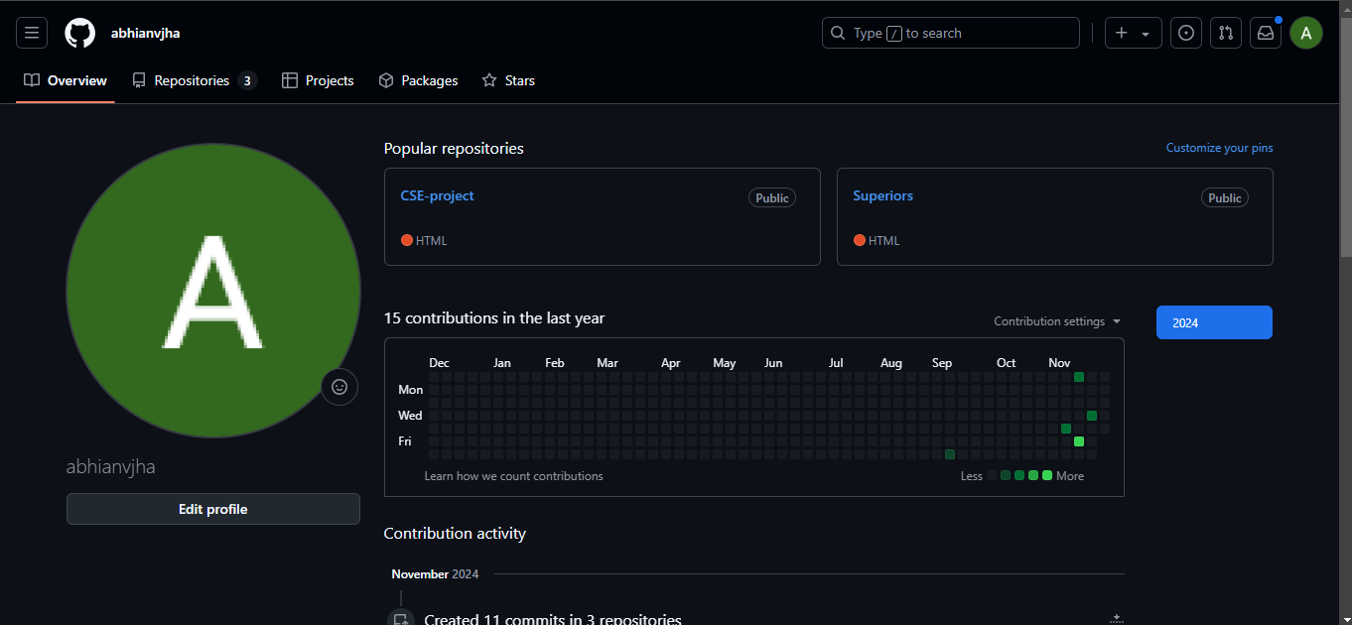
Accomplishment:

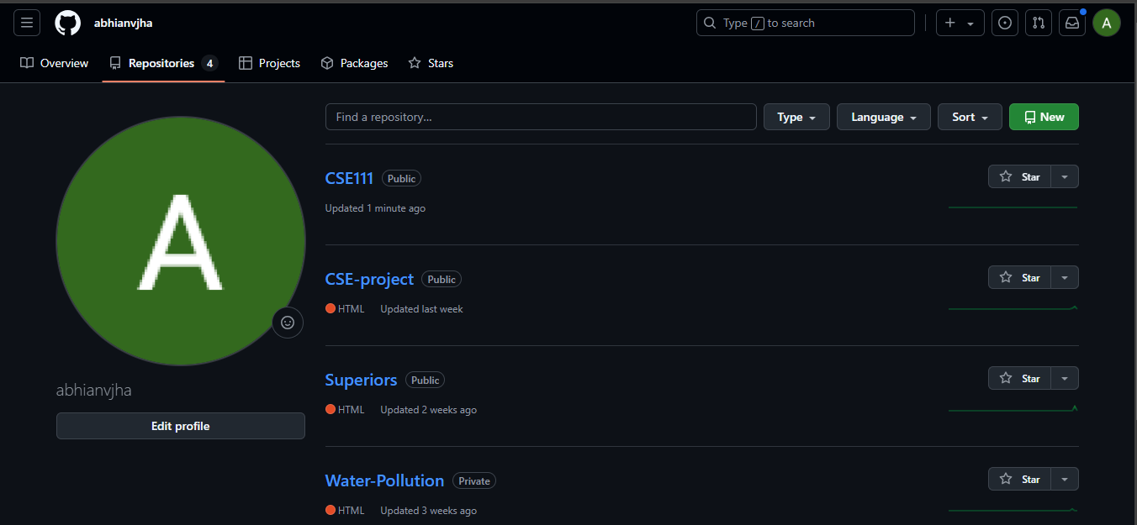

GIT
Accomplishment:
Created a repository and committed a file a in it .
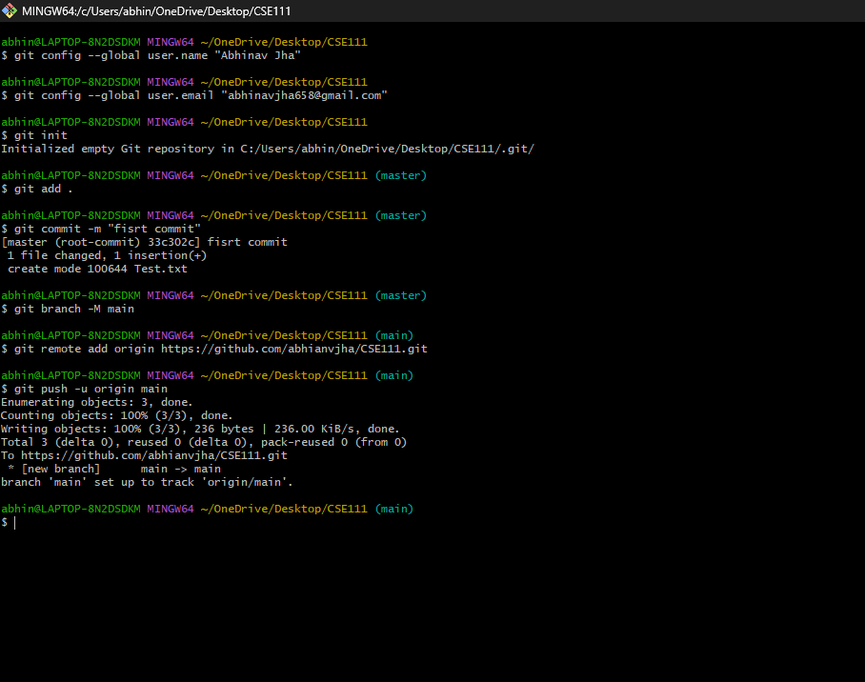

9

CV
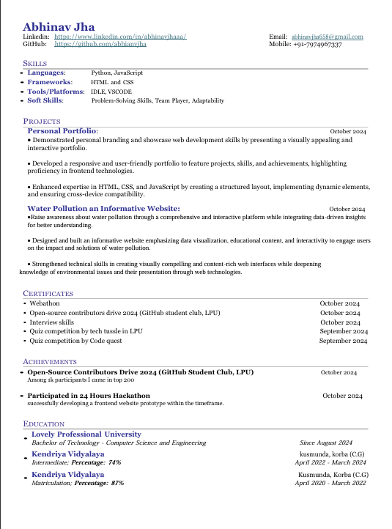

10

Technical MOOCS registration Link and screenshot: -
Link: - https://skillera.org/ExploreCoursesEthicalHacking

